**Application and Messaging Service**

1. SNS (Simple Notification Service)
   1. SES (Simple Email Service)
2. SQS (Simple Queue Service)
3. Amazon MQ (Amazon Message Queue)
4. SWF (Simple Work Flow)
5. API Gateway
6. **SNS**
   1. Application Interface -> SNS -> Create Topic -> Give a endpoint
      1. Subscribers can subscribe to the endpoint
         1. URL
         2. Post/send
         3. Email address
         4. SQS
         5. Mobile push messages (to send email notification)
         6. Lambda msgs
         7. Sms text messages

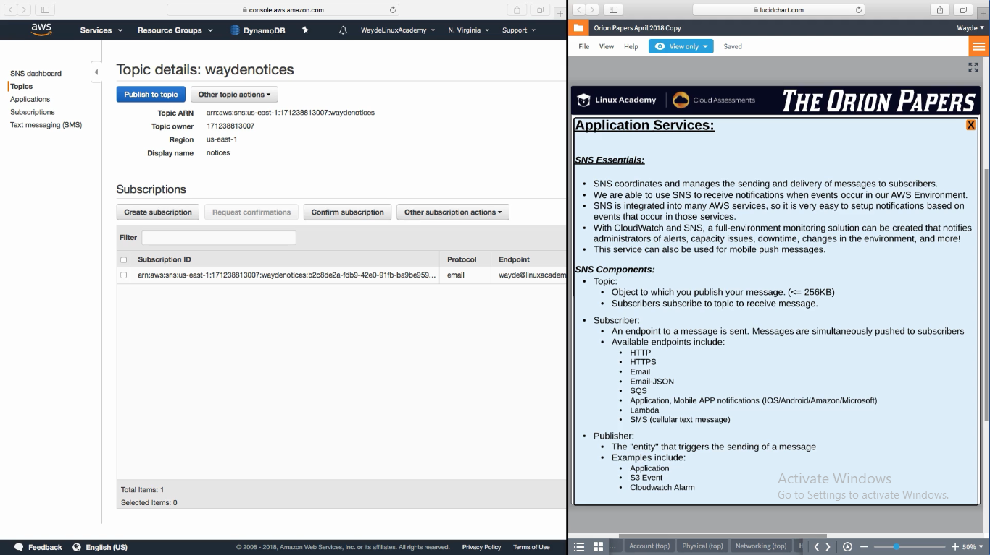

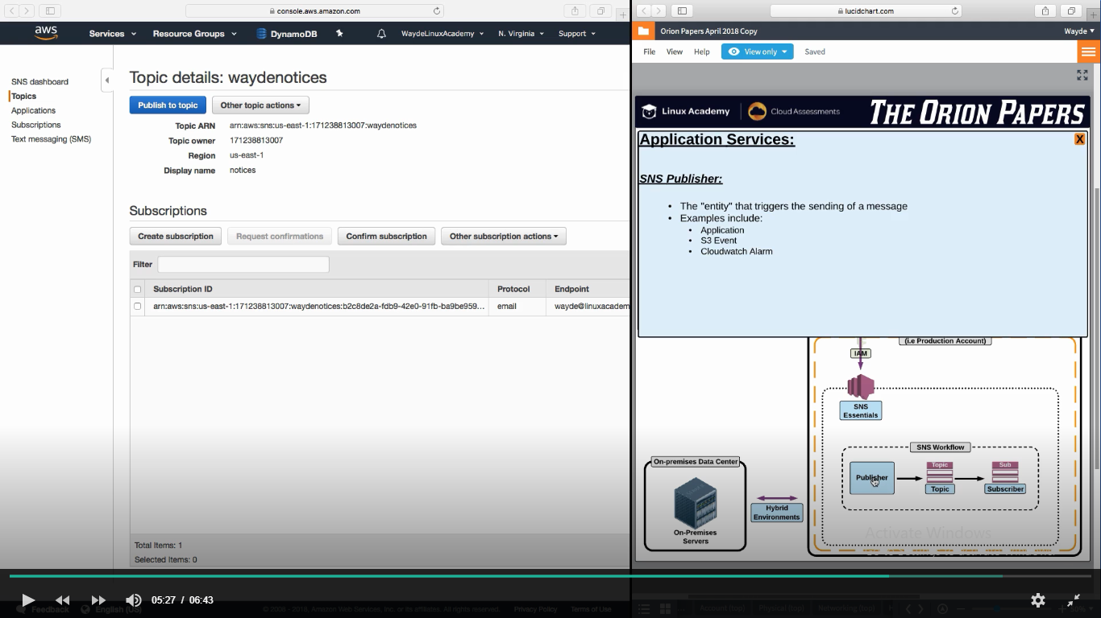

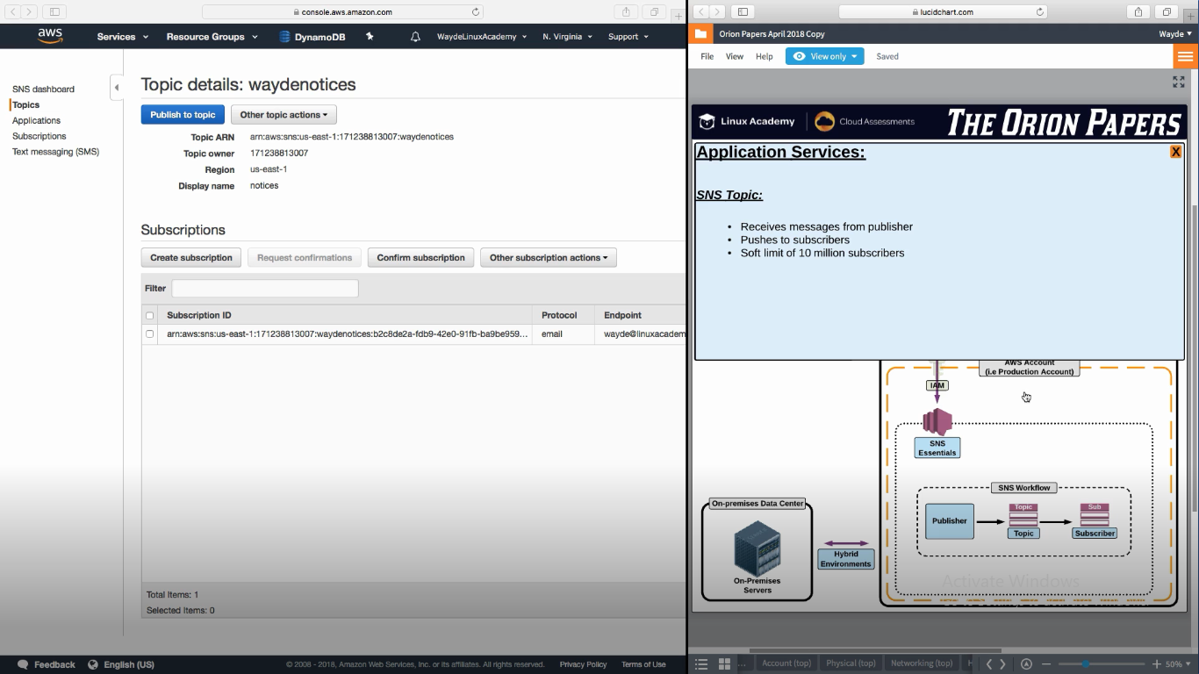

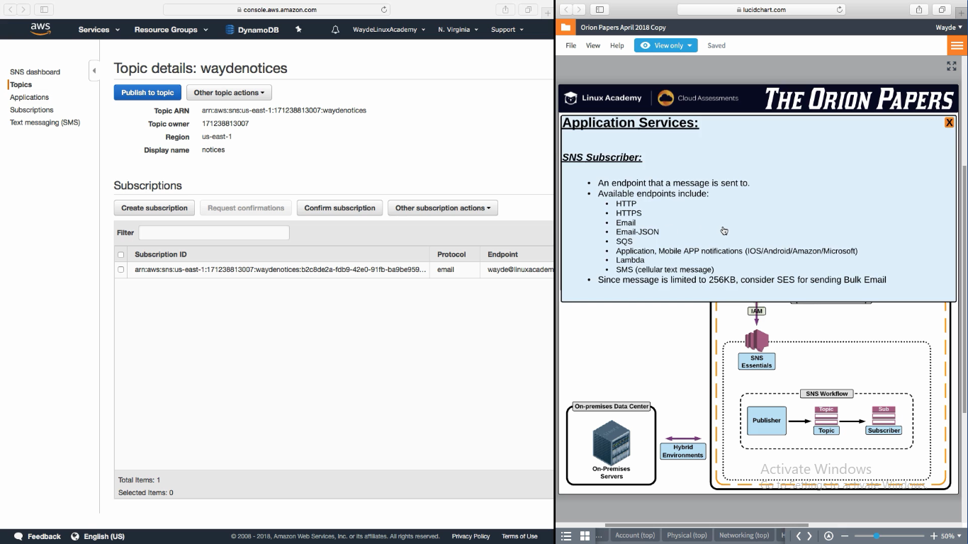

1. **SQS – Simple Queue Service**

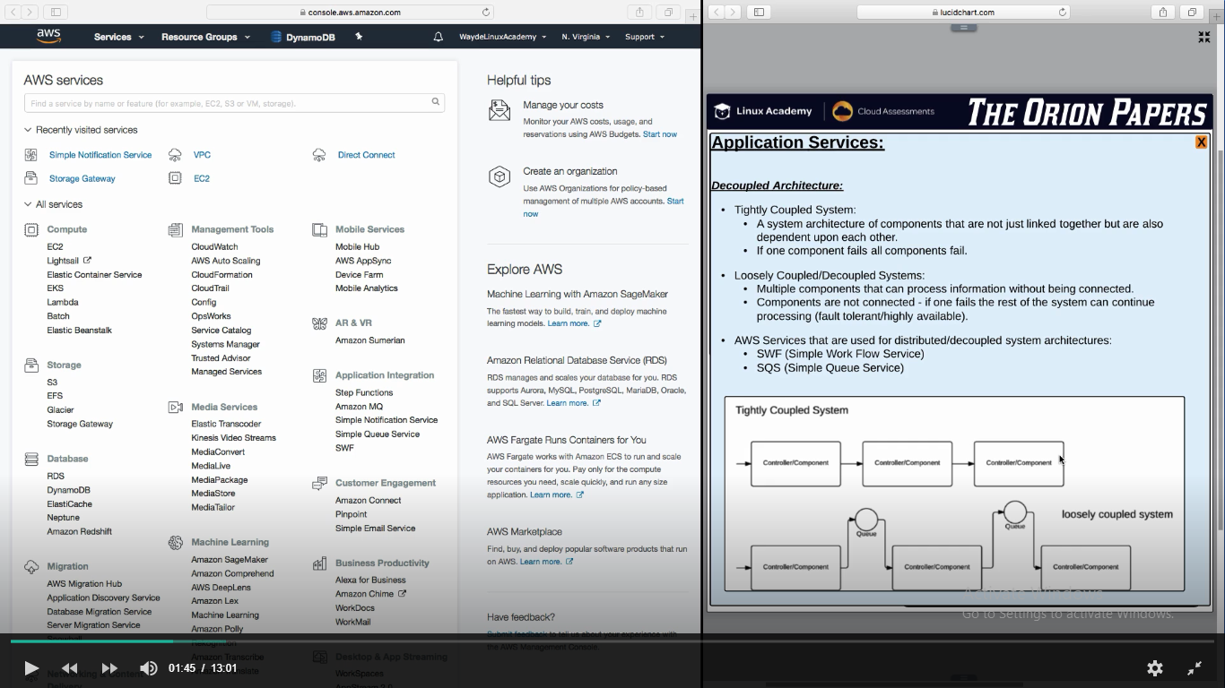

* 1. Provides a queue to write msg
  2. Worker instance when have opportunity to some work, will read the msg in the queue by poling the queue and then do whatever msg instructs
  3. It should be a HA queue across AZ
  4. Set Visibility time out on the queue for the worker instance to come to queue and read the msg. If that time lapse msg goes back to the queue and another worker node will try to read it

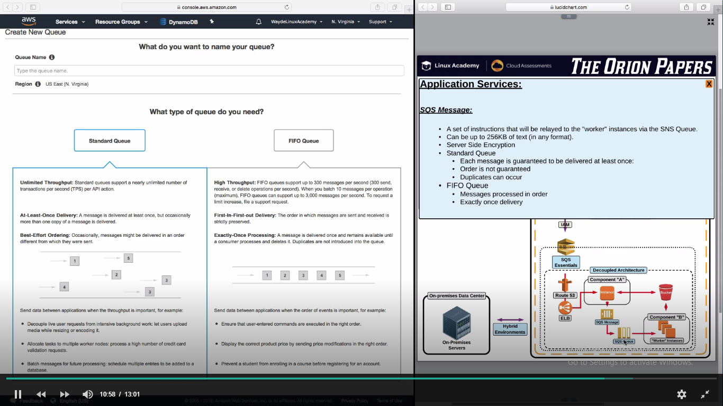

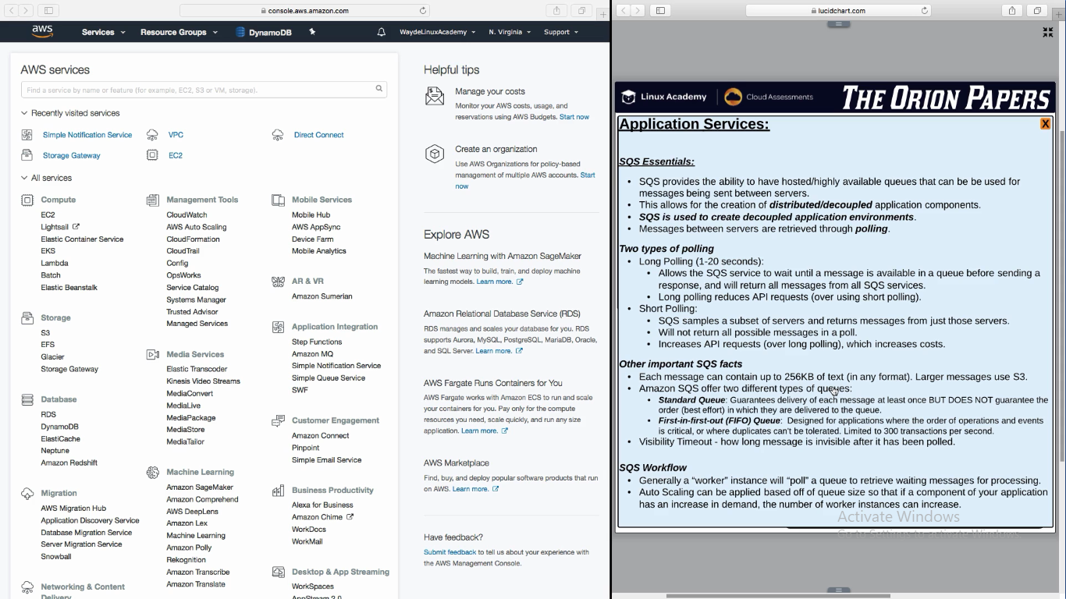

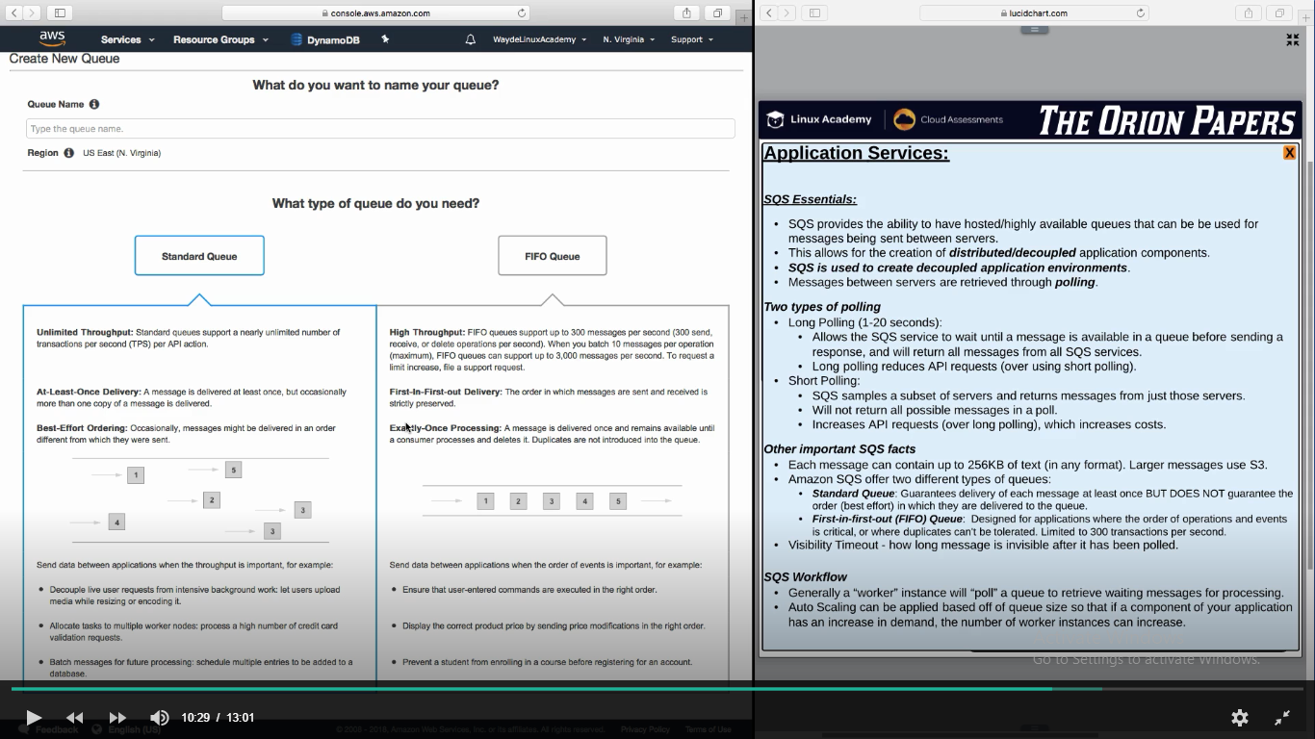

**SNS and SQS can work to gather**

SNS topic will have multiple SQS as subscribers

So one message will be sent to multiple SQS queue. Worker nodes process each message in each queue. So one messages is processes in two queue for different purpose.

**Amazon Message Queue Service (Amazon MQ service)**

1. This uses apache MQ broker. Here we can initialize a Apache MQ broker and create topic and queue and add subscribers
2. Not scalable as like SNS or SQS
3. It runs on one single instance. It is not scalable. But we can make it HA by making one instance in one zone and another instance in another zone

Creation steps MQ broker in AWS console:

1. Create broker
2. Attach it to a VPC and SG. It take 15 min to create
3. By default runs in 8162 port

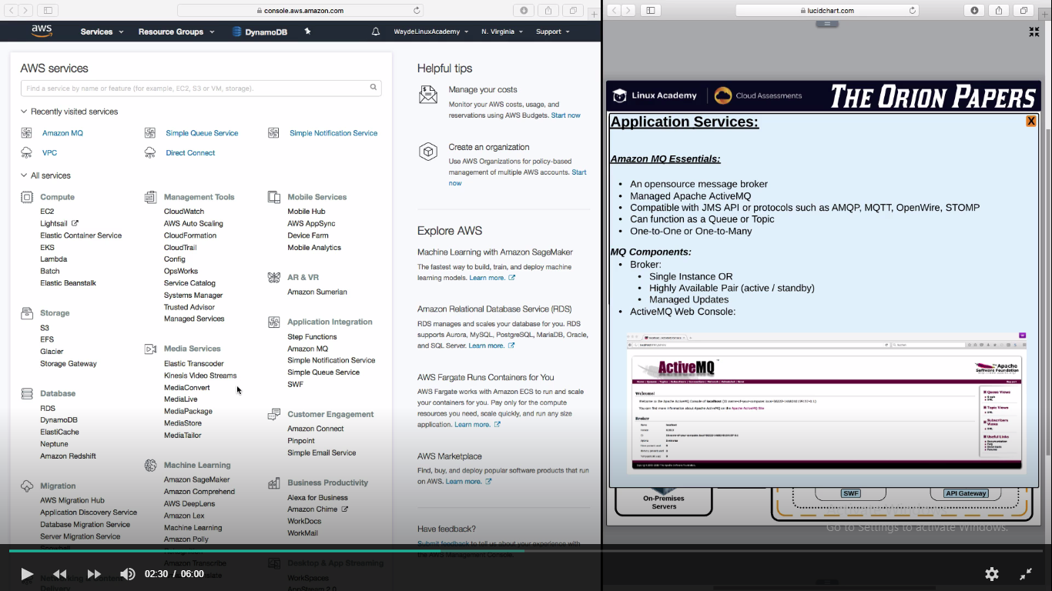

This will be running in one single instance. We can have another standby instance if this instance goes down. So Amazon Message Queue is not HA.

AWS Console -> Application Integration -> Amazon Message Queue -> Create

Give a name, select instance type, select singe instance or active/standby mode

Select VPC, Subnet and security group

It takes 15 min to create it

It will give the url of AMQ web console

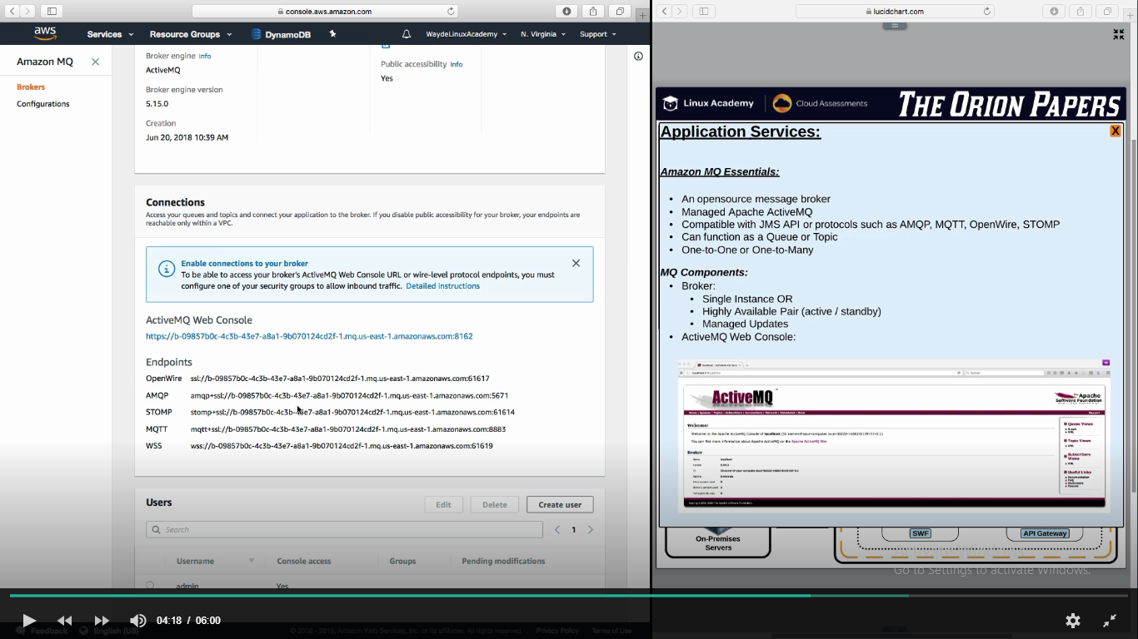

AMQ will run in port 8162.

TCP : 8162 make it open

Login to the console. It will be available in the queue configuration which we created.

You can create a queue/topic subscribers etc.

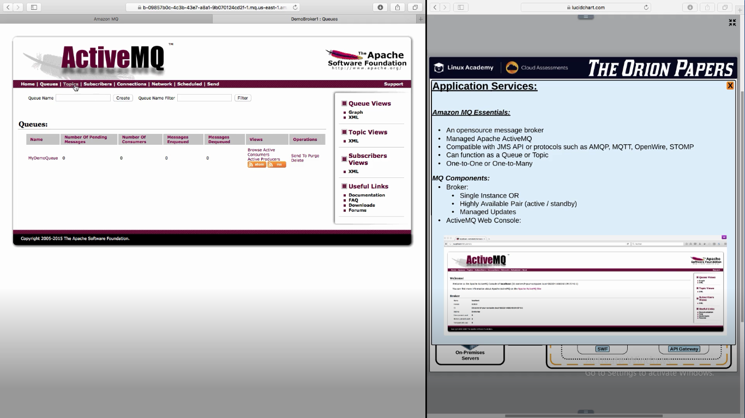

**SWF (Simple Work Framework)**

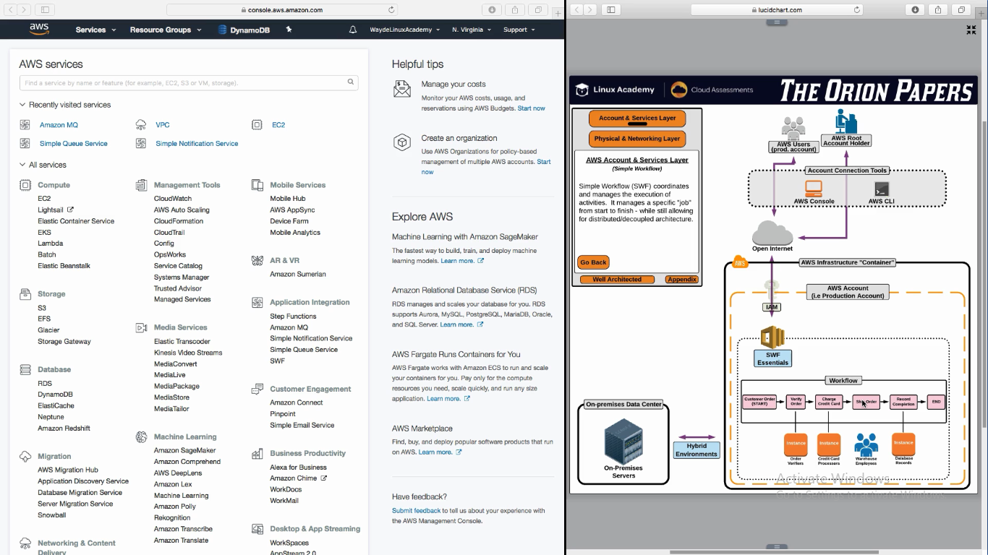

**SWF**

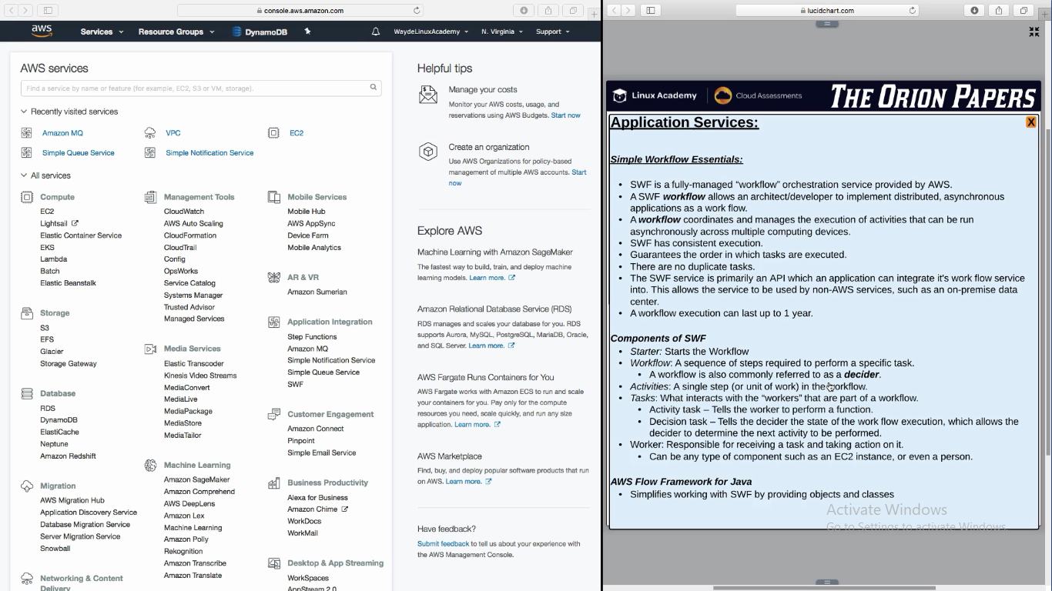

**SNS Handson**

AWS Console -> Application Integration -> Simple Notification Service -> Get Started -> Create Topic

Enter Topic name

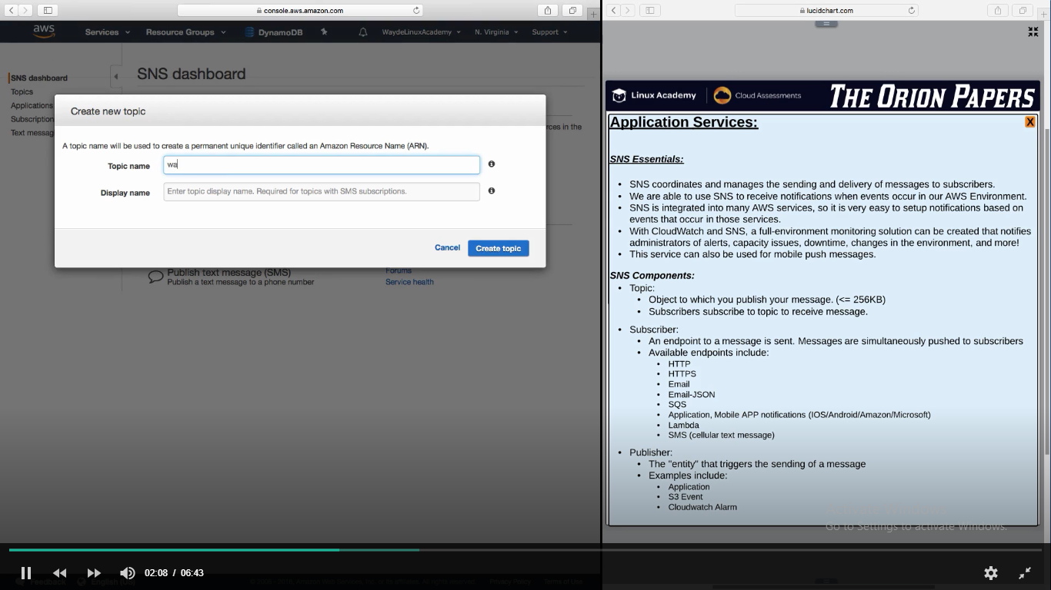

Once created, click on “Create Subscription” and give the endpoint (sms, email etc)

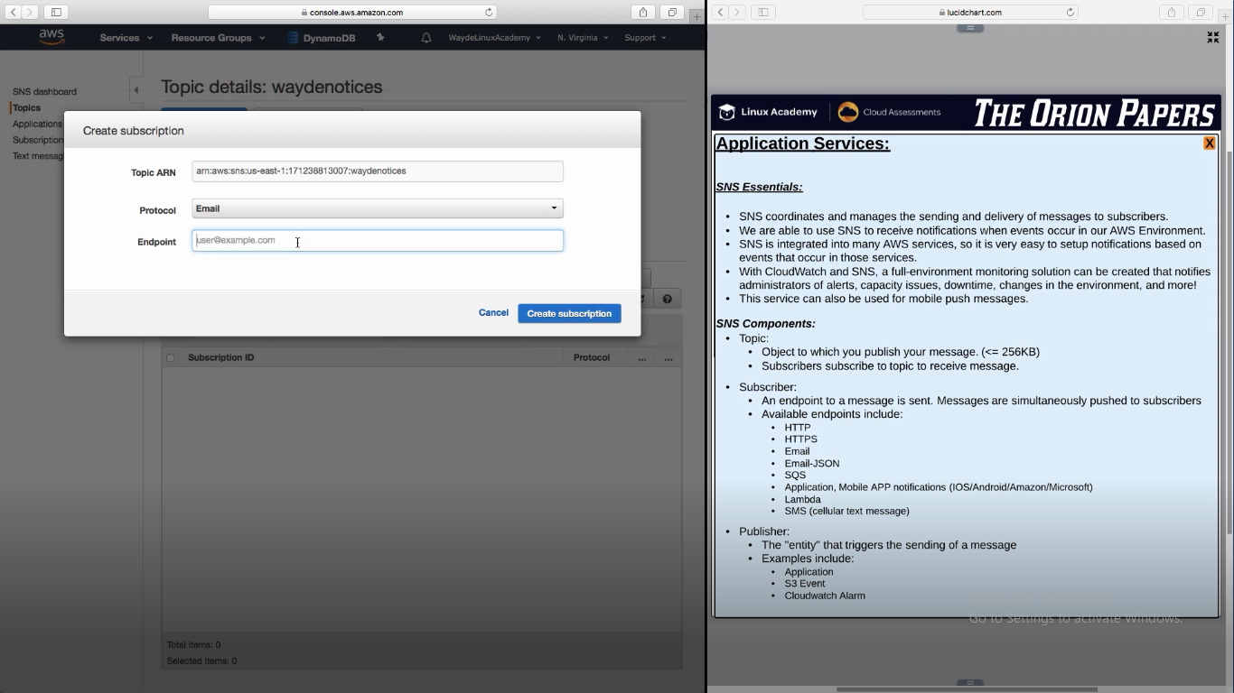

Publisher will publish msg to the topic.

Subscribers will receive the msg

